**TRIGGERS**

Exp No: 10 Writing triggers

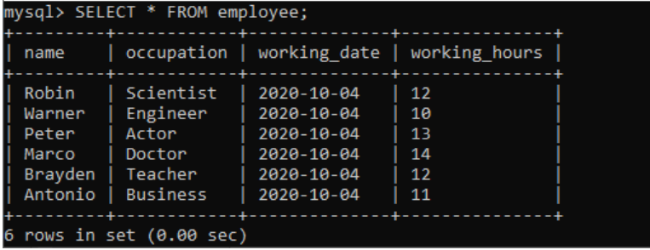

CREATING TRIGGERS

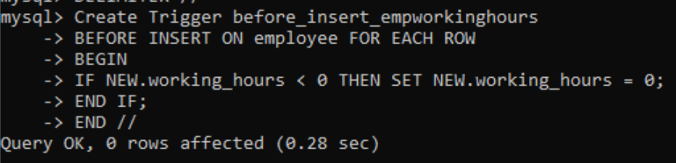

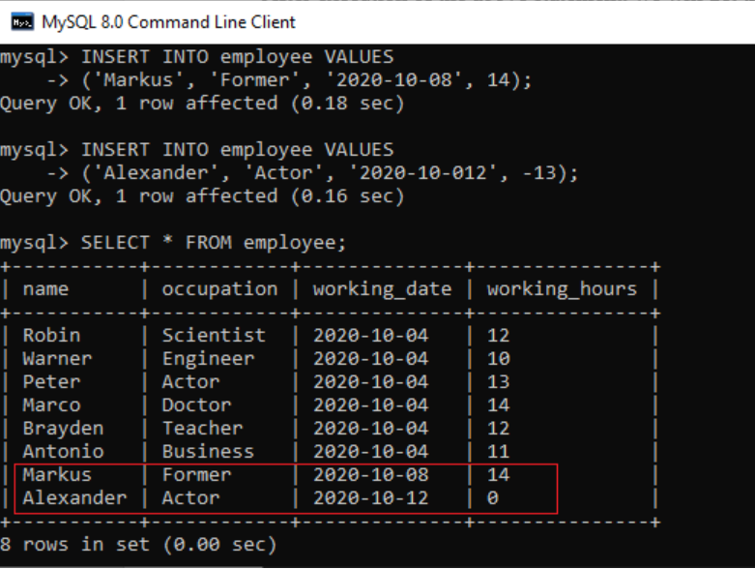

LIST TRIGGERS

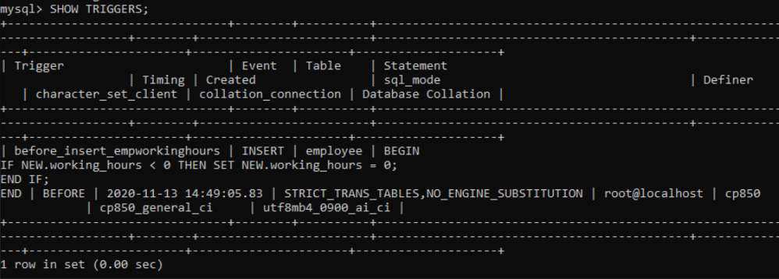

DROP TRIGGER

